IRMA Solved Paper 2007
Directions for next five questions: In the following number series only one number is wrong. Find out the wrong number.
51, 26, 29, 42, 86, 217.5
A. 29
B. 217.5
C. 86
D. 42
E. None of these
4, 7, 24, 196, 5488, 1075648
A. 24
B. 1075648
C. 196
D. 5488
E. None of these
288, 432, 648, 972, 1456, 2187
A. 2187
B. 648
C. 1456
D. 972
E. None of these
12, 35, 136, 677, 4010, 28045
A. 4010
B. 677
C. 136
D. 28045
E. None of these
93, 309, 434, 498, 521, 533
A. 533
B. 498
C. 434
D. 309
E. None of these
18 men can complete a piece of work in 63 days. 9 women take 189 days to complete the same piece of work. How many days will 4 men, 9 women and 12 children together take to complete the piece of work if 7 children alone can complete the piece of work in 486 days?
A. 76
B. 63
C. 54
D. 81
E. None of these
The total compound interest earned on an amount @ 15 p.c.p.a. at the end of three years is Rs 9844.5375. What is the amount?
A. Rs 17,500
B. Rs 18,900
C. Rs 19,700
D. Rs 19,400
E. None of these
A shopkeeper sold an Air-conditioner for Rs 25,935 with a discount of 9% and earned a profit of 3.74%. What would have been the percentage of profit earned if no discount were offered?
A. 15.6%
B. 16%
C. 12.3%
D. Cannot be determined
E. None of these
Directions for next five questions: In the following questions two equations numbered I and II are given. You have to solve both the equations and
I.
II.
A.
B.
C.
D.
E. p q or the relationship between p andq cannot be established.

I. 4p + 3q = 19
II. 5p + 5q = 27
A.
B.
C.
D.
E. p q or the relationship between p and q cannot be established.
I.
II.
A.
B.
C.
D.
E. p q or the relationship between p and q cannot be established.
I.
II.
A.
B.
C.
D.
E. p q or the relationship between p and q cannot be established
I.
II.
A.
B.
C.
D.
E. p q or the relationship between p and q cannot be established.
Directions for next five questions: What should come in place of the question mark (?) in the following questions?
A. 1862.26
B. 406.54
C. 533.43
D. 2080.83
E. None of these
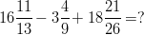
A. 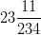
B. 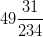
C. 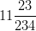
D. 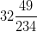
E. None of these
A. 34
B. 614656
C. 28
D. 784
E. None of these
37.1% of 780 â€“ ?% of 280 = 12% of 322
A. 49.8
B. 37.6
C. 52.4
D. 39.6
E. None of these
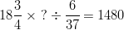
A. 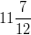
B. 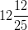
C. 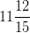
D. 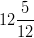
E. None of these
A farmer owns a circular plot with diameter 56 metres. He builds a 7 metres wide garden around (outside) the plot which costs Rs 260 per square metre. What is the total cost borne by the farmer for building the entire garden?
A. Rs 4,16,550
B. Rs 2,28,700
C. Rs 4,08,220
D. Rs 3,60,360
E. None of these
In a year, a man manages to sell only 65% of the chicken he owns. How many chicken should the man own to sell 47,775 chicken in a year?
A. 73,000
B. 68,500
C. 82,500
D. 55,000
E. None of these
Directions for next five questions: What approximate value should come in place of the question mark (?) in the following questions?
A. 17
B. 43
C. 22
D. 11
E. 35
A. 24
B. 18
C. 30
D. 12
E. 45
18.2% of 547 + 23.6% of 128.5 = ?
A. 116
B. 158
C. 121
D. 130
E. 148
A. 1520
B. 1580
C. 1480
D. 1420
E. 1450
A. 16
B. 142
C. 166
D. 29
E. 108
Directions for next five questions: Study the table carefully to answer the following questions.
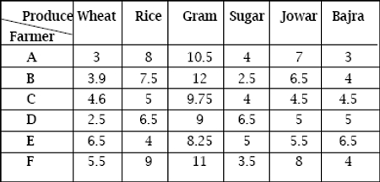
If farmer D sells 40 kilos of each of the six produces, what is the total money earned by him?
A. Rs 1,260
B. Rs 1,540
C. Rs 1,360
D. Rs 1,480
E. None of these
Which produce has the lowest average selling price?
A. Wheat
B. Sugar
C. Jowar
D. Bajra
E. None of these
If each farmer sells 250 kilos of Wheat and 150 Kilos of Gram, which farmer earns the maximum money?
A. B
B. C
C. E
D. F
E. None of these
Farmer B sells 170 kilos of Jowar and 120 kilos of Bajra. Farmer A sells 120 kilos of Jowar and 170 kilos of Bajra. What is the difference between the total money earned by each farmer from both produces together?
A. Rs 145
B. Rs 260
C. Rs 235
D. Rs 195
E. None of these
Average selling price of sugar is approximately what per cent of average selling price of rice?
A. 64%
B. 76%
C. 52%
D. 48%
E. 83%
Directions for next five questions: Study the graph carefully to answer the following questions.
Per cent profit earned by two Potters over the years
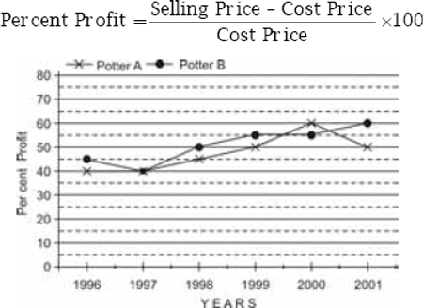
If Potter A sold 3,650 pots in the year 1999 at the price of Rs 12 per pot, what is the cost price of all pots together?
A. Rs 22,600
B. Rs 28,500
C. Rs 25,300
D. Rs 29,200
E. None of these
If the amount of profit earned by Potter B in the year 1996 is Rs 40,500, what was the selling price of all the pots in that year?
A. Rs 1,30,500
B. Rs 2,06,200
C. Rs 1,44,500
D. Rs 1,87,500
E. None of these
If in the year 2000, the total selling price of Potter B is equal to the total cost price of Potter A, what is the respective ratio of their selling prices?
A. 7 : 8
B. 5 : 8
C. 5 : 7
D. 7 : 9
E. None of these
Which of the following statement(s) is/are definitely true?
A. Amount of profit earned by Potter B in the year 1999 and 2000 is the same
B. Potter A earned the highest amount of profit in the year 2000
C. Amount of profit earned by Potter A and B is the same in the year 1997
D. All of the above
E. None of these
What is the approximate per cent rise in per cent profit of Potter B in the year 2001 from the previous year?
A. 16%
B. 4%
C. 9%
D. 19%
E. 12%
Directions for next five questions: Study the table carefully to answer the following questions.
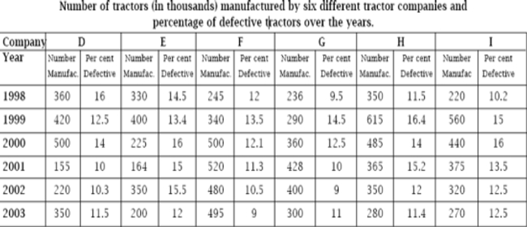
What is the respective ratio of non-defective tractors manufactured by Company G in the year 1999 to the non-defective tractors manufactured by Company E in the same year?
A. 4366 : 6225
B. 4959 : 6928
C. 6225 : 4366
D. 6928 : 4959
E. None of these
What is the total number of defective tractors manufactured by Company H over the years?
A. 13,38,410
B. 4,27,340
C. 3,12,568
D. 4,41,534
E. None of these
In which year were maximum number of tractors manufactured?
A. 1998
B. 2001
C. 2003
D. 2000
E. None of these
Which Company has manufactured the lowest number of defective tractors over the years?
A. F
B. I
C. G
D. D
E. None of these
Total number of non-defective tractors manufactured by Company F over the years is approximately what per cent of the total tractors manufactured by it over the years?
A. 78
B. 94
C. 66
D. 89
E. 72
Directions for next five questions: Study the graph carefully to answer the following questions.
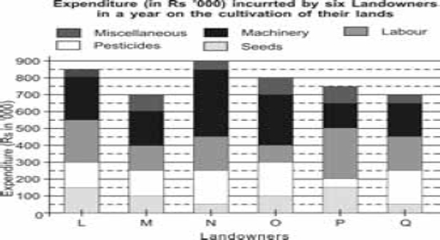
What is the amount of expenditure incurred by P on Machinery?
A. Rs 1,00,000
B. Rs 15,000
C. Rs 2,00,000
D. Rs 25,000
E. None of these
+The amount of expenditure incurred by L on pesticides is what per cent of the amount of expenditure incurred by Q on pesticides?
A. 75
B. 60
C. 50
D. 85
E. None of these
What is the total amount of expenditure incurred on Labour by all Landowners together?
A. Rs 12,000
B. Rs 1,20,000
C. Rs 12,00,000
D. Rs 1,200
E. None of these
Expenditure on Seeds by Q is approximately what per cent of its total expenditure?
A. 12
B. 18
C. 3
D. 7
E. 15
Miscellaneous expenditure incurred by all Landowners together is approximately what per cent of the total expenditure incurred on all items together by all Landowners?
A. 6
B. 10
C. 15
D. 20
E. 17
Directions for next five questions: Study the information carefully to answer the questions that follow.
In a school of 2,500 students, the students are taught four different languages viz., English, Hindi, Marathi and Sanskrit. The ratio of girls to boys in the school is 3 : 2 respectively. 16% of the boys learn only Marathi. 23% of the girls learn only Marathi and Hindi. 14% of the total number of students learn only English. Boys learning only Marathi and Hindi are 120% of the girls learning the same. One-tenth of the boys learn only Sanskrit. Girls learning only Marathi are 130% of the boys learning the same. 19% of the boys learn only English. Remaining boys learn only Sanskrit, Hindi and English. 32% of the girls learn only Hindi and Sanskrit. Remaining girls learn only Hindi, English and Sanskrit.
What is the total number of girls learning English and Sanskrit?
A. 787
B. 867
C. 947
D. 897
E. None of these
What is the total number of students learning Marathi?
A. 1017
B. 1464
C. 1024
D. 1127
E. None of these
How many students study at least two languages at a time?
A. 1582
B. 1462
C. 1670
D. 1550
E. None of these
What is the total number of boys learning Hindi?
A. 480
B. 550
C. 620
D. 650
E. None of these
How many girls do not learn Hindi?
A. 368
B. 416
C. 346
D. 428
E. None of these

